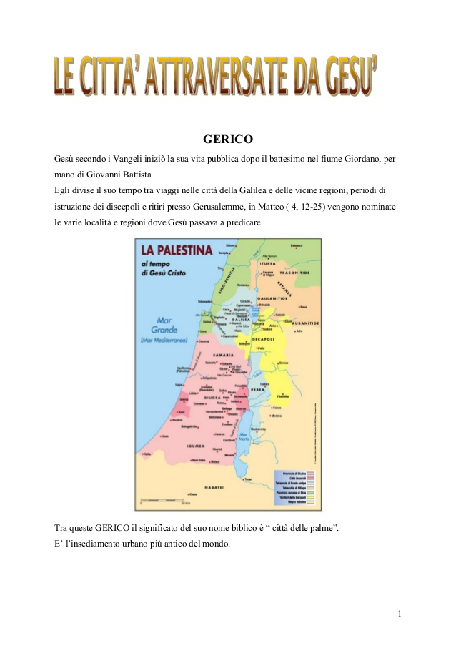

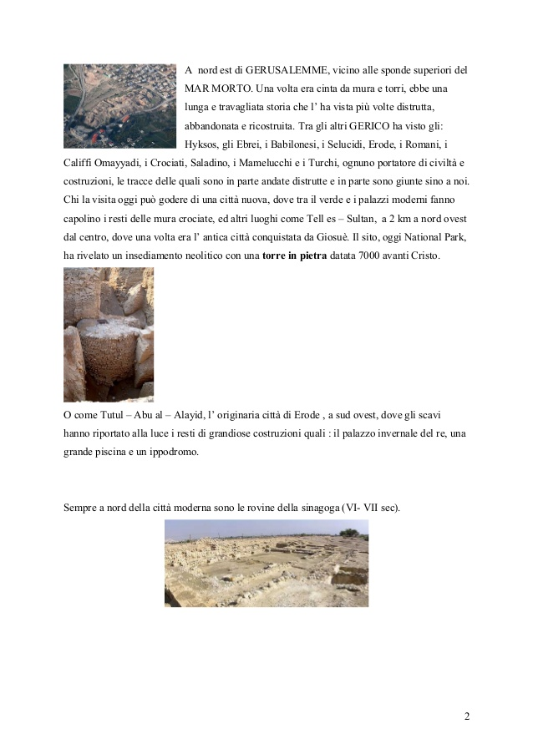

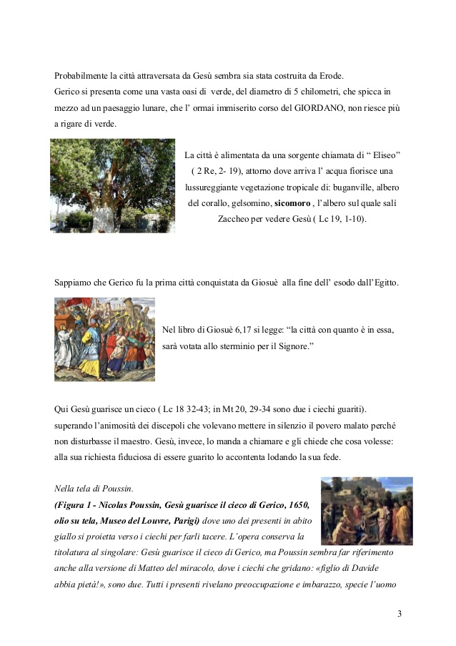

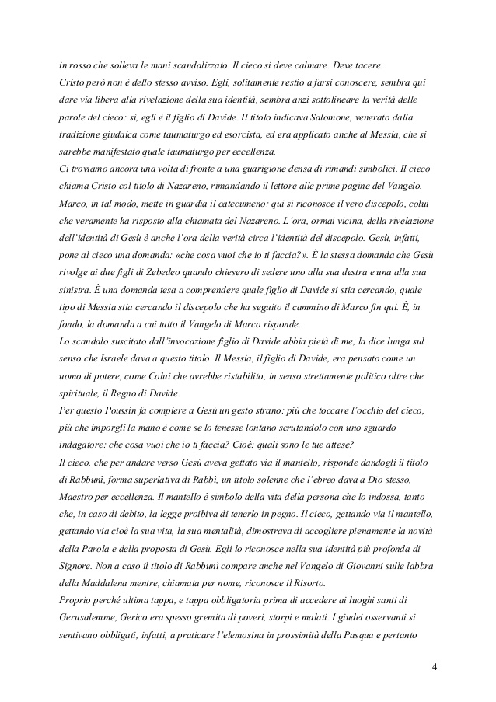

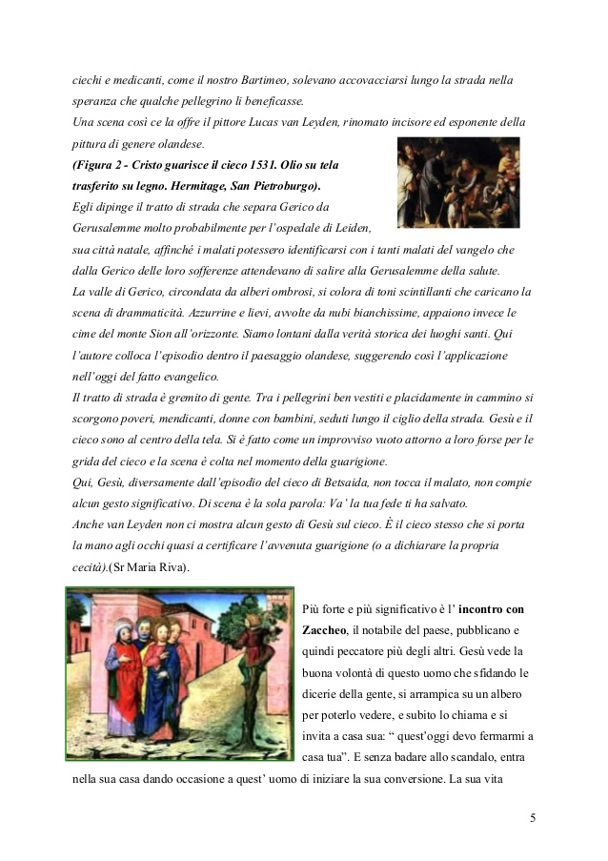

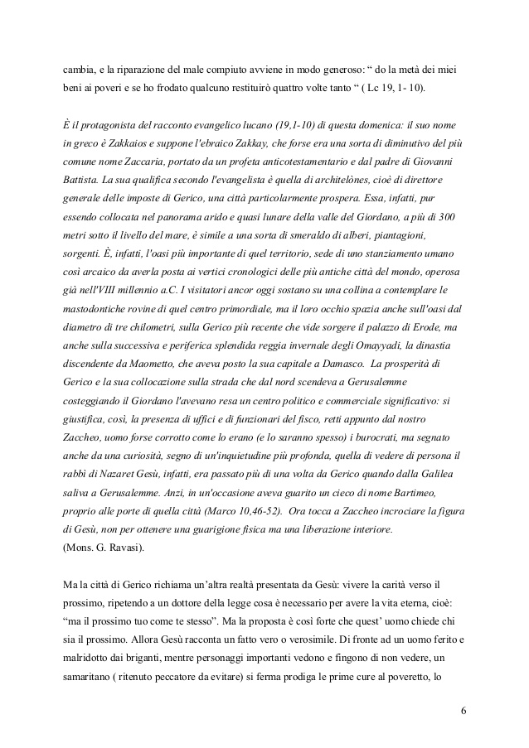

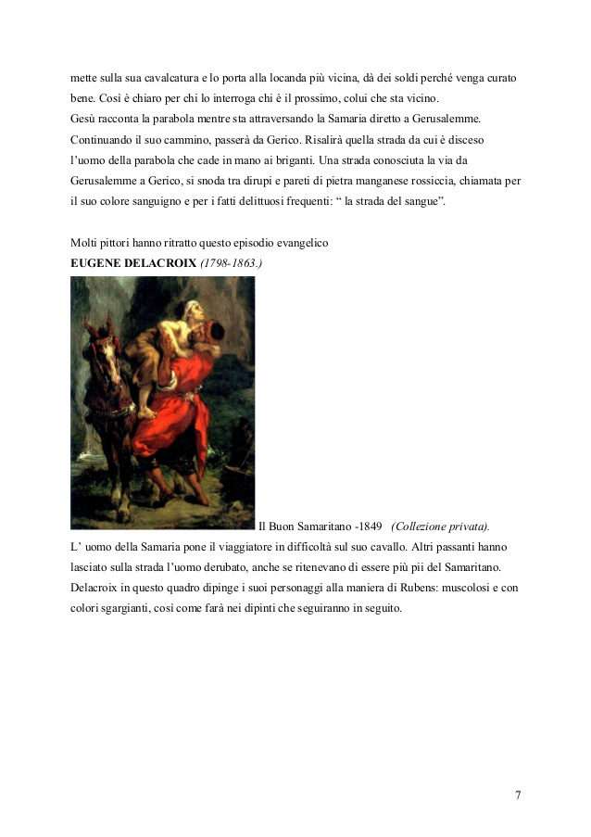

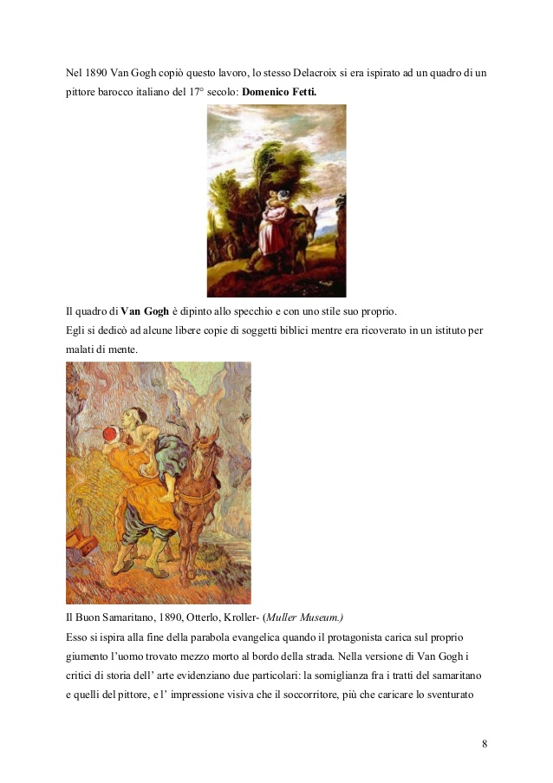

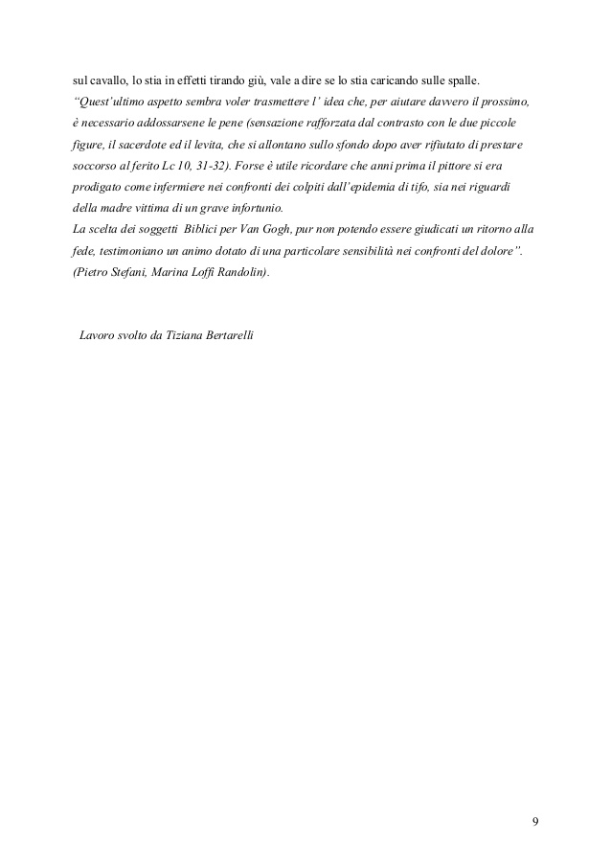

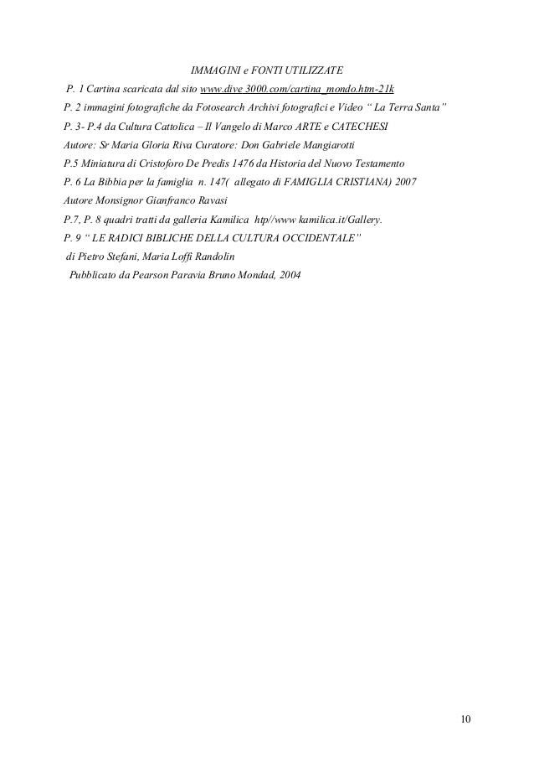

/10

[Like](http://www.slideshare.net/signup?from_source=http%3A%2F%2Fwww.slideshare.net%2Fslideshow%2Fembed_code%2F29466767) [Share](http://www.slideshare.net/slideshow/embed_code/29466767)[Save](http://www.slideshare.net/signup?from_source=http%3A%2F%2Fwww.slideshare.net%2Fslideshow%2Fembed_code%2F29466767)

Like this ? Why not share!

* Share
* Email

* [[](http://www.slideshare.net/enricogalavotti/i-malati-dei-vangeli)I malati dei vangeliby Liceo Linguistico...607 views](http://www.slideshare.net/enricogalavotti/i-malati-dei-vangeli)
* [[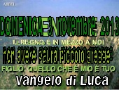](http://www.slideshare.net/ParrocchiaMen/avvisi-villa-dadige-04-10112013)Avvisi villa d'adige 04 10.11.2013by Parrocchia Menà115 views](http://www.slideshare.net/ParrocchiaMen/avvisi-villa-dadige-04-10112013)
* [[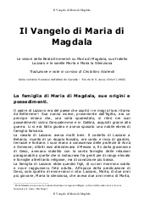](http://www.slideshare.net/cristoforoandreoli/il-vangelo-di-maria-di-magdala)Il vangelo di maria di magdalaby Cristoforo Andreoli201 views](http://www.slideshare.net/cristoforoandreoli/il-vangelo-di-maria-di-magdala)
* [[](http://www.slideshare.net/enricogalavotti/umano-e-politico)Umano e politicoby Liceo Linguistico...825 views](http://www.slideshare.net/enricogalavotti/umano-e-politico)
* [[](http://www.slideshare.net/ParrocchiaMen/avvisi-mena-29-4112012)Avvisi mena' 29 4.11.2012by Parrocchia Menà186 views](http://www.slideshare.net/ParrocchiaMen/avvisi-mena-29-4112012)
* [[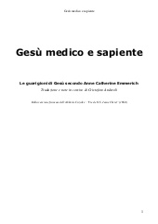](http://www.slideshare.net/cristoforoandreoli/ges-medico-e-sapiente)Gesù medico e sapienteby Cristoforo Andreoli240 views](http://www.slideshare.net/cristoforoandreoli/ges-medico-e-sapiente)
* [[](http://www.slideshare.net/paoluc/ges-20)Gesù 2.0by paoluc5007 views](http://www.slideshare.net/paoluc/ges-20)
* [[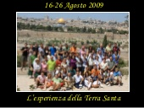](http://www.slideshare.net/fulviobramb/terra-santa09)Terra Santa'09by Fulvio1464 views](http://www.slideshare.net/fulviobramb/terra-santa09)
* [[](http://www.slideshare.net/ParrocchiaMen/avvisi-mena-21-27102013)Avvisi mena' 21 27.10.2013by Parrocchia Menà100 views](http://www.slideshare.net/ParrocchiaMen/avvisi-mena-21-27102013)
* [[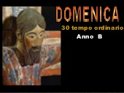](http://www.slideshare.net/ParrocchiaMen/avvisi-villa-dadige-29-4112012)Avvisi villa d'adige 29 4.11.2012by Parrocchia Menà147 views](http://www.slideshare.net/ParrocchiaMen/avvisi-villa-dadige-29-4112012)
* [[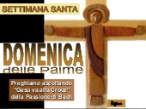](http://www.slideshare.net/enzo54/palme-dom-a)Palme dom aby Don Enzo Di Nardi575 views](http://www.slideshare.net/enzo54/palme-dom-a)
* [[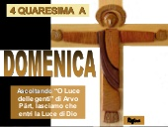](http://www.slideshare.net/enzo54/4-qua-a)4 qua aby Don Enzo Di Nardi321 views](http://www.slideshare.net/enzo54/4-qua-a)

Share Embed

* Facebook
* Twitter
* LinkedIn
* Google
* Pinterest
* Wordpress

**Email this SlideShare**

Inizio modulo



Add Message



Fine modulo

Email Sent! Send Another



Generate embed code for https site

Size (px): 

Start on Slide: 

Show related SlideShares at end

Shortcode for WordPress.com blogs [ [?](http://help.slideshare.com/entries/20117147-can-i-embed-slideshare-presentations-in-wordpress-blogs-or-which-embed-code-should-i-use-for-my-word) ] 

Share Embed

* Facebook
* Twitter
* LinkedIn
* Google
* Pinterest
* Wordpress

**Email this SlideShare**

Inizio modulo



Add Message



Fine modulo

Email Sent! Send Another



Generate embed code for https site

Size (px): 

Start on Slide: 

Show related SlideShares at end

Shortcode for WordPress.com blogs [ [?](http://help.slideshare.com/entries/20117147-can-i-embed-slideshare-presentations-in-wordpress-blogs-or-which-embed-code-should-i-use-for-my-word) ] 