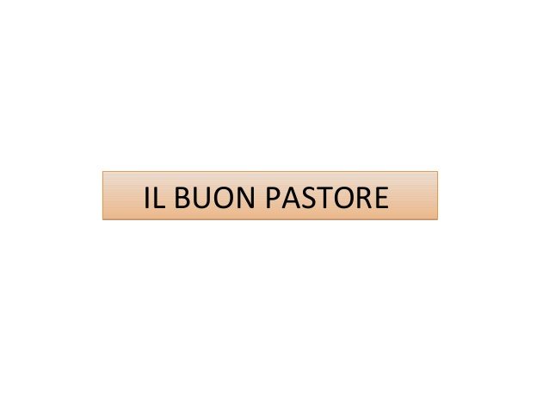
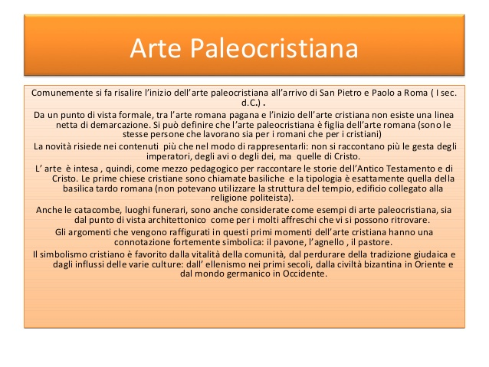
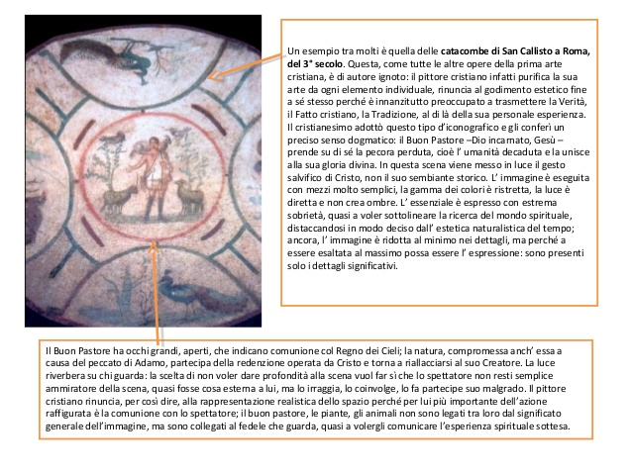
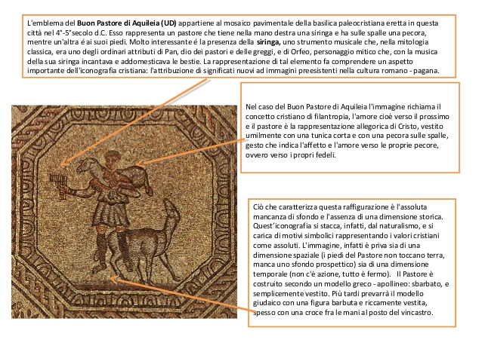
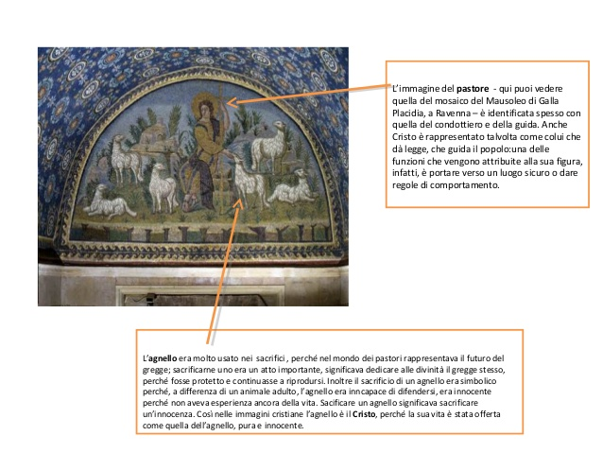
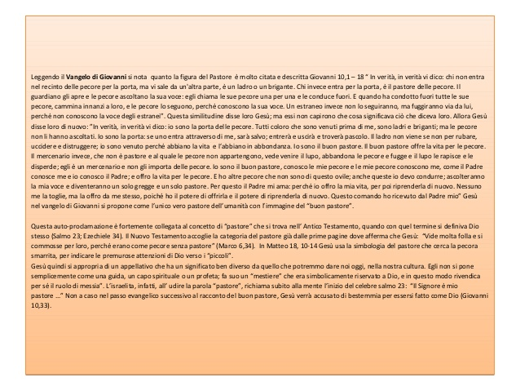
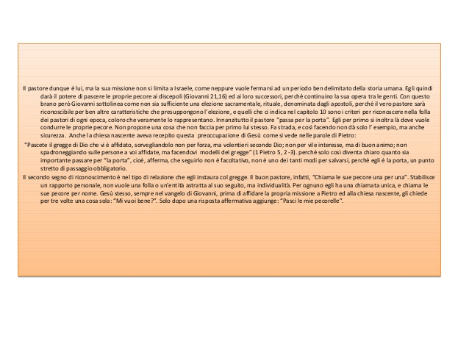
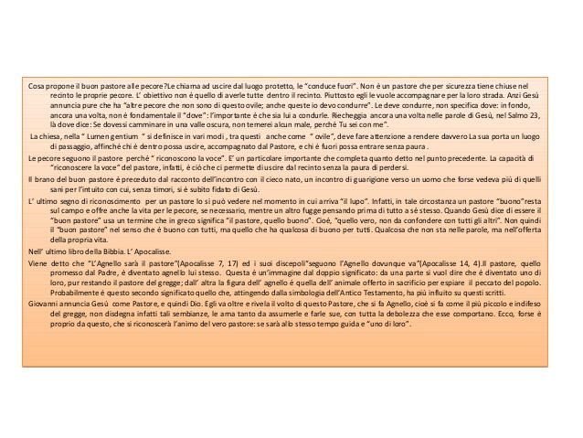
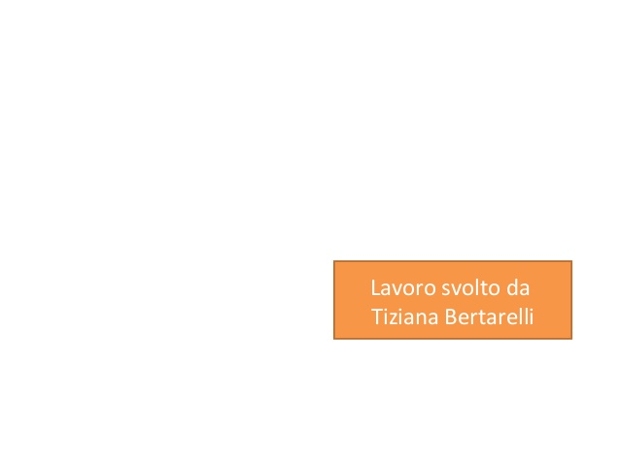

« ‹ › »
/10
Like ShareSave

